**Image processing & Machine Vision**

**Assignment Report**

**Assignment - I**

MPSM Pathirana

D/ENG/22/0061/EE

Department of Electrical, Electronic and Telecommunication Engineering

**Content**

1. Question 01
2. Question 02
3. Question 03
4. Question 04
5. Question 05
6. Question 06
7. Question 07
8. Question 08
9. GitHub link

**Question 02**

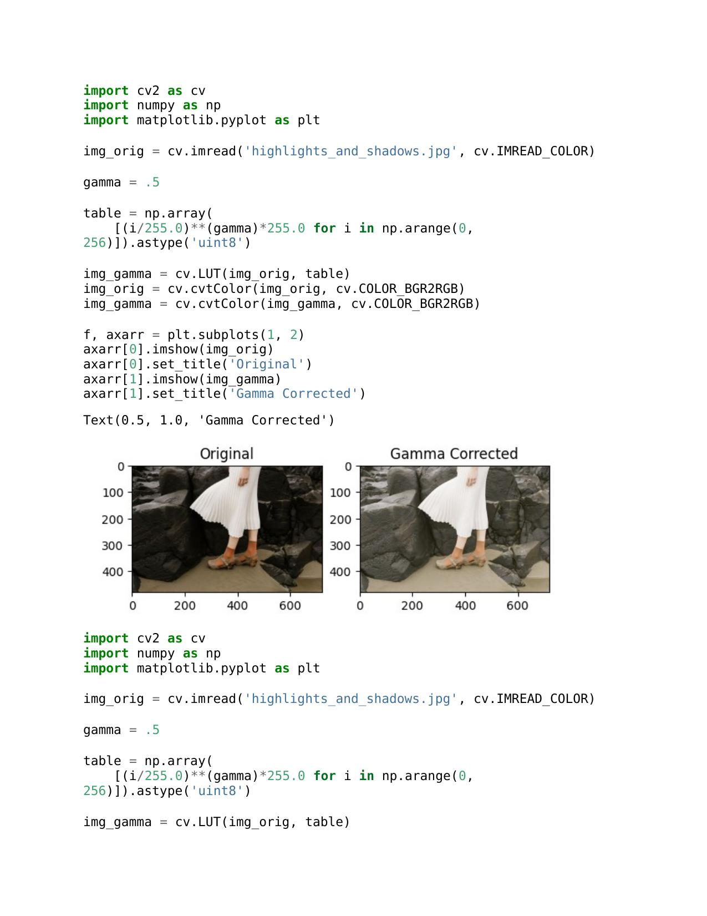

a.

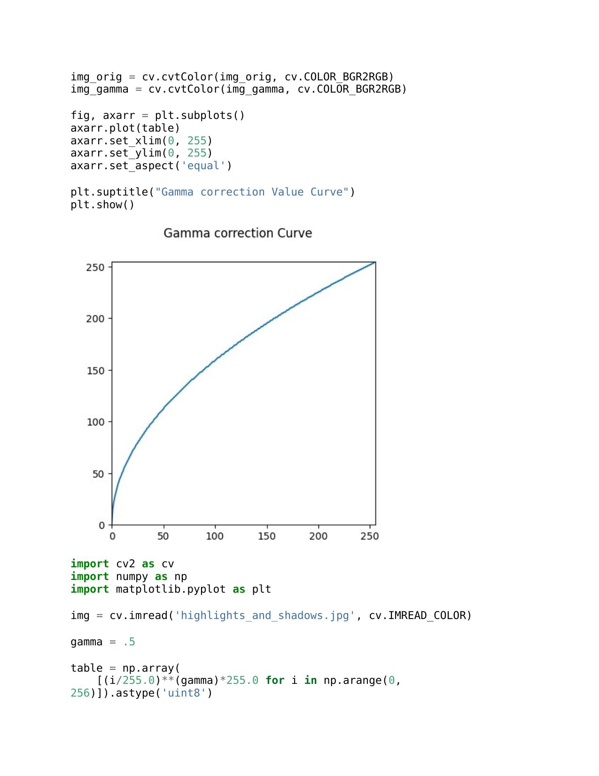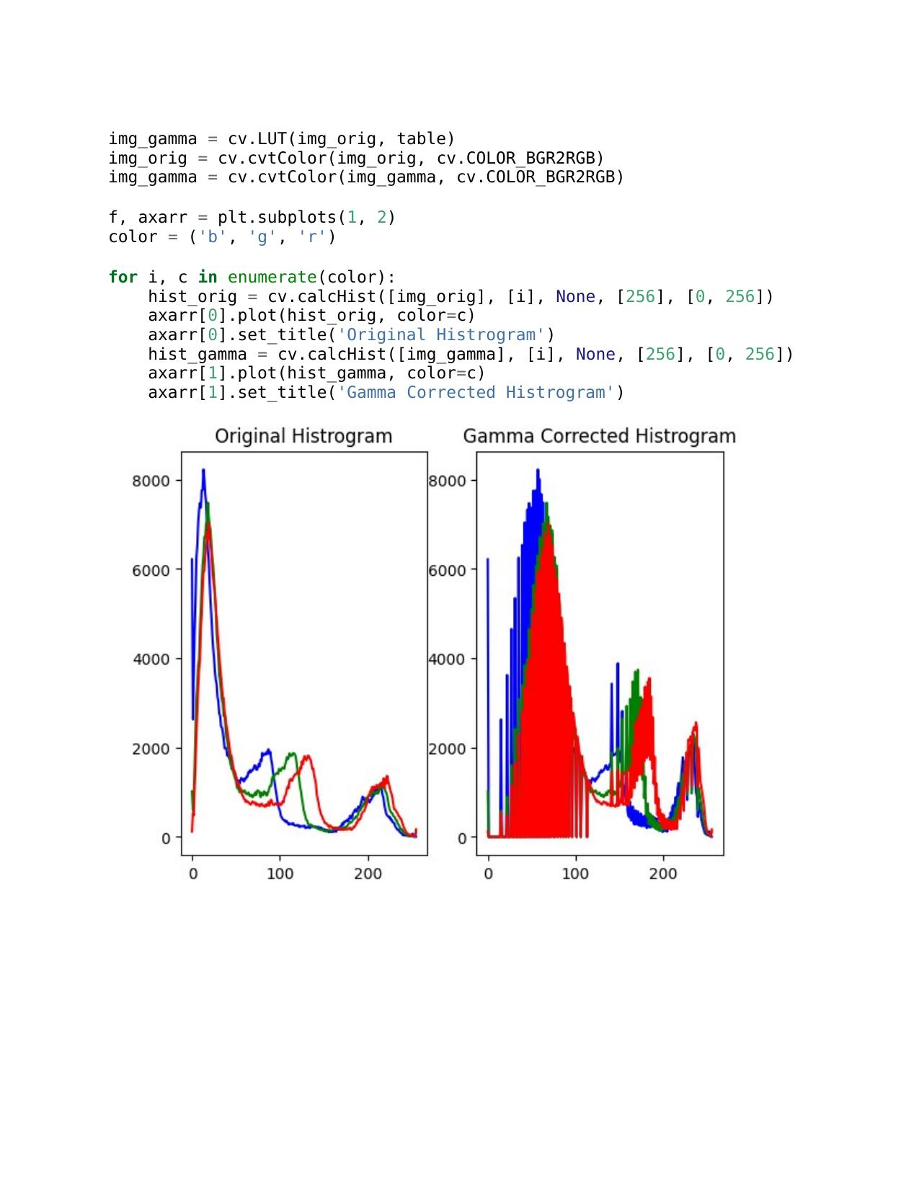

b...

a.

b...

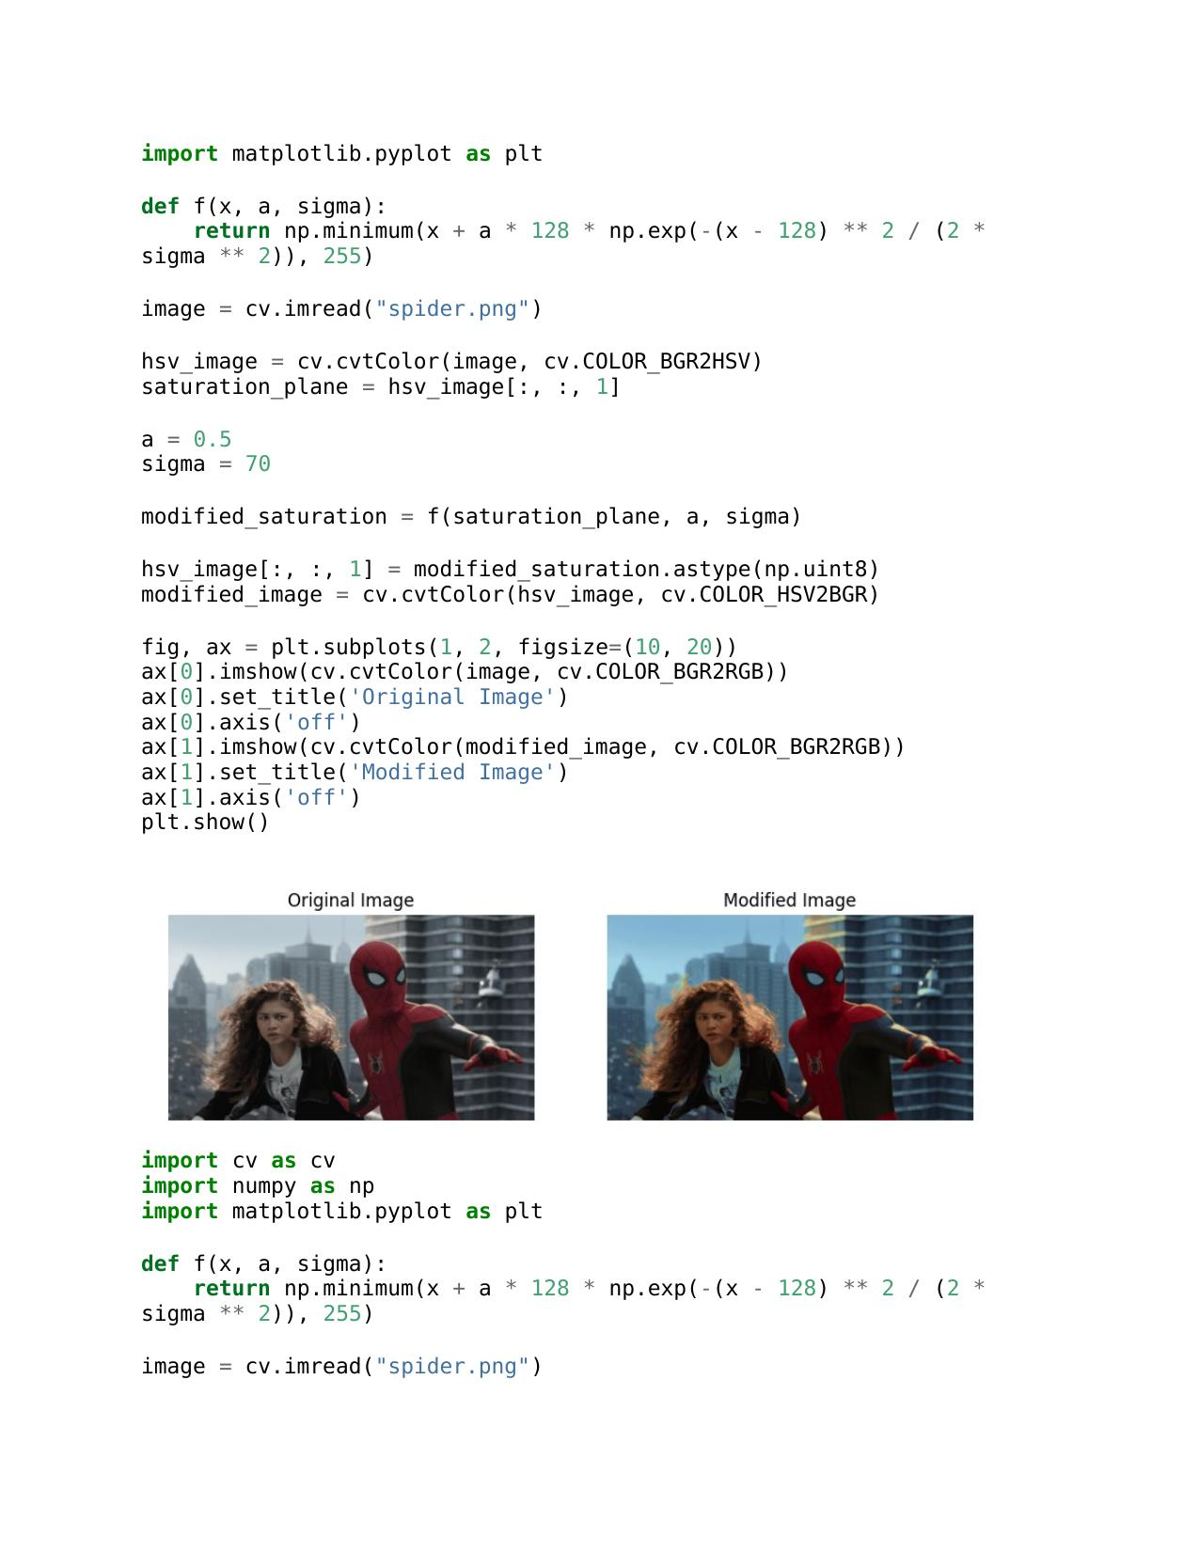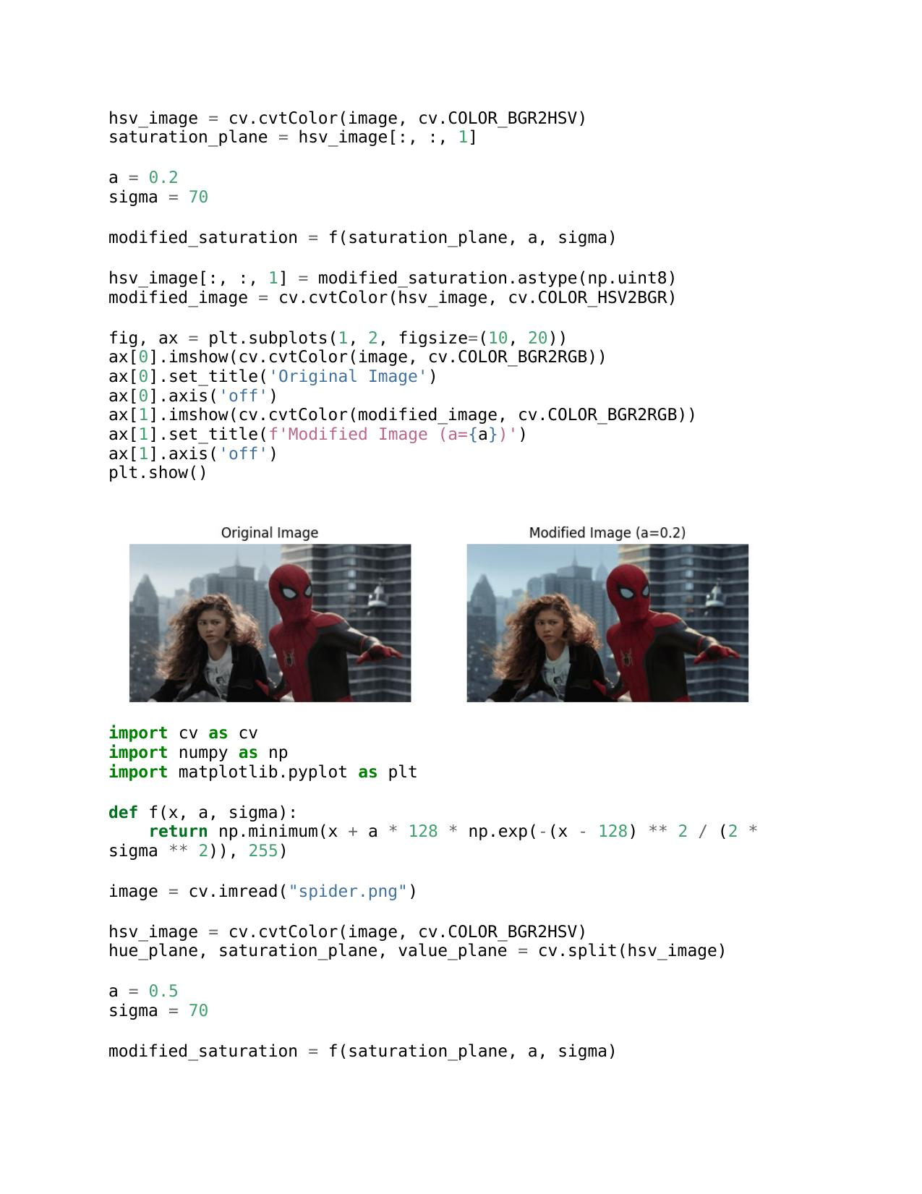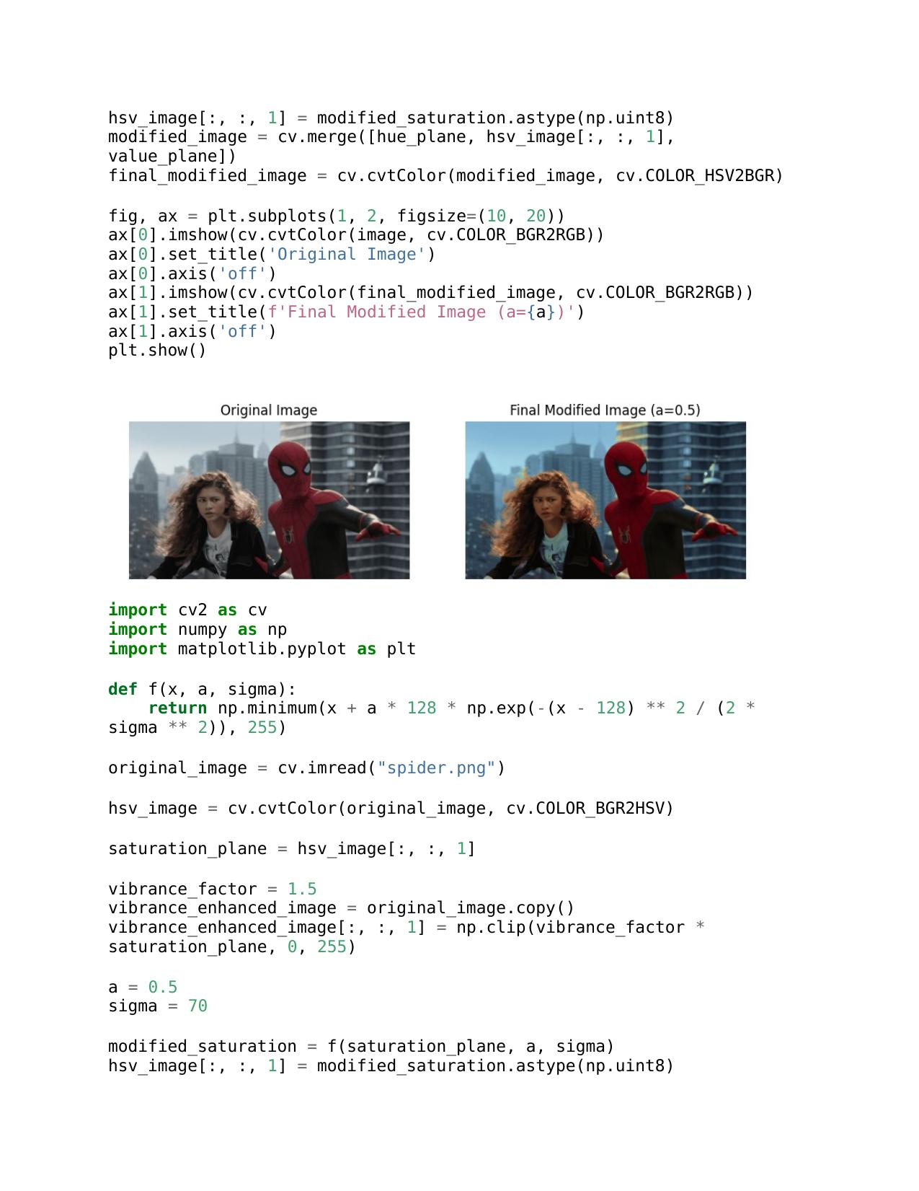

c.

d.

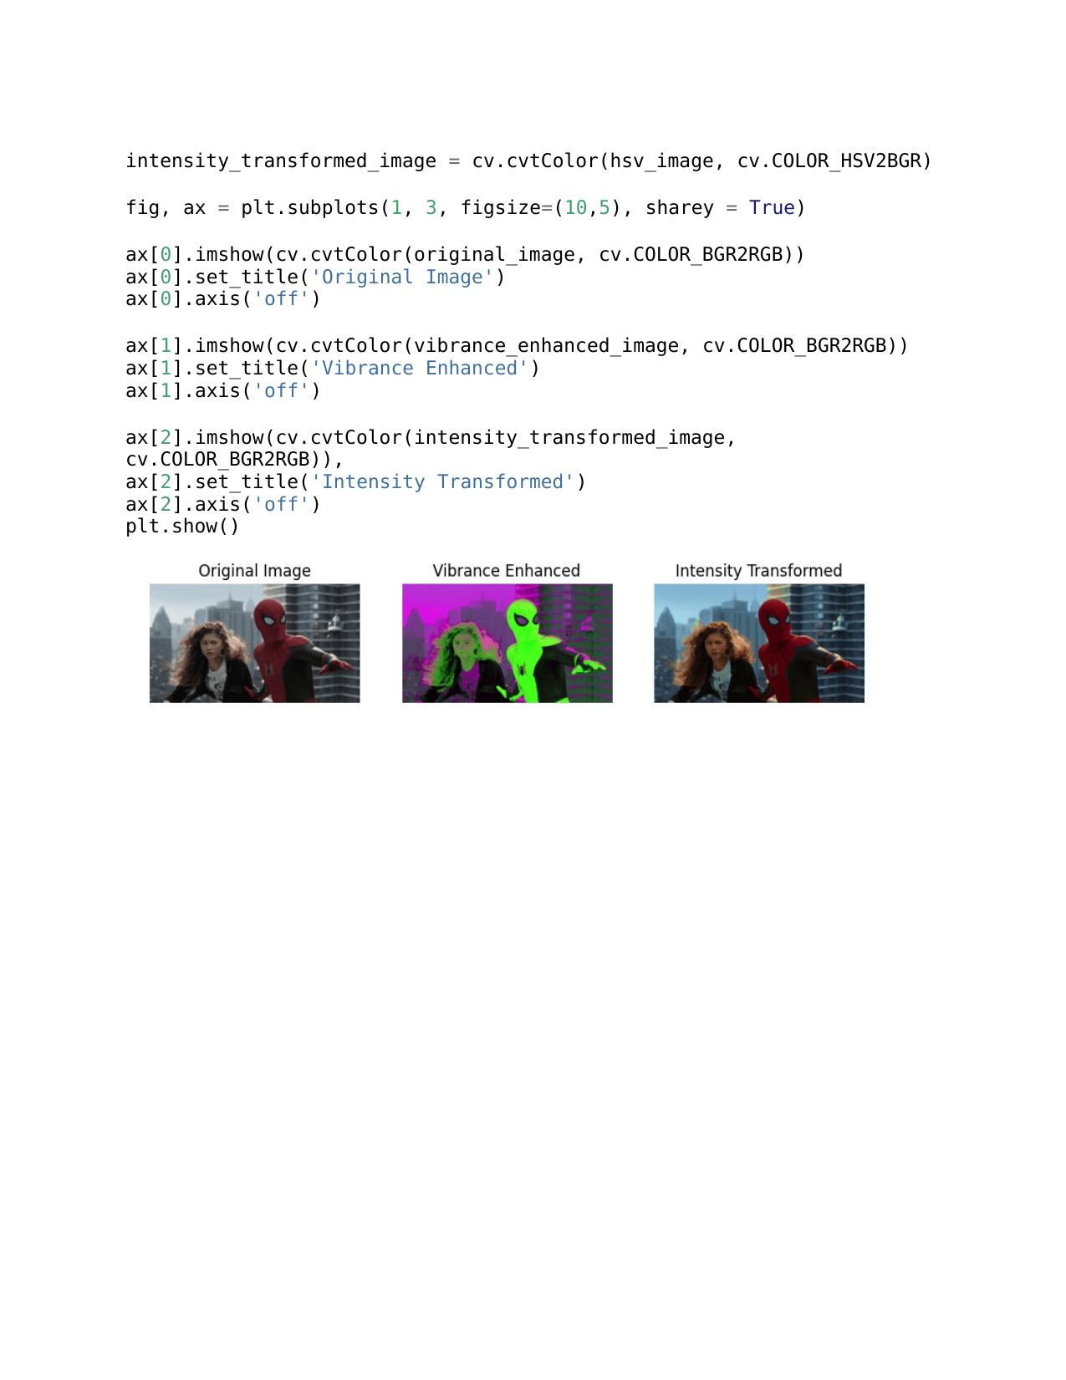

**Question 04**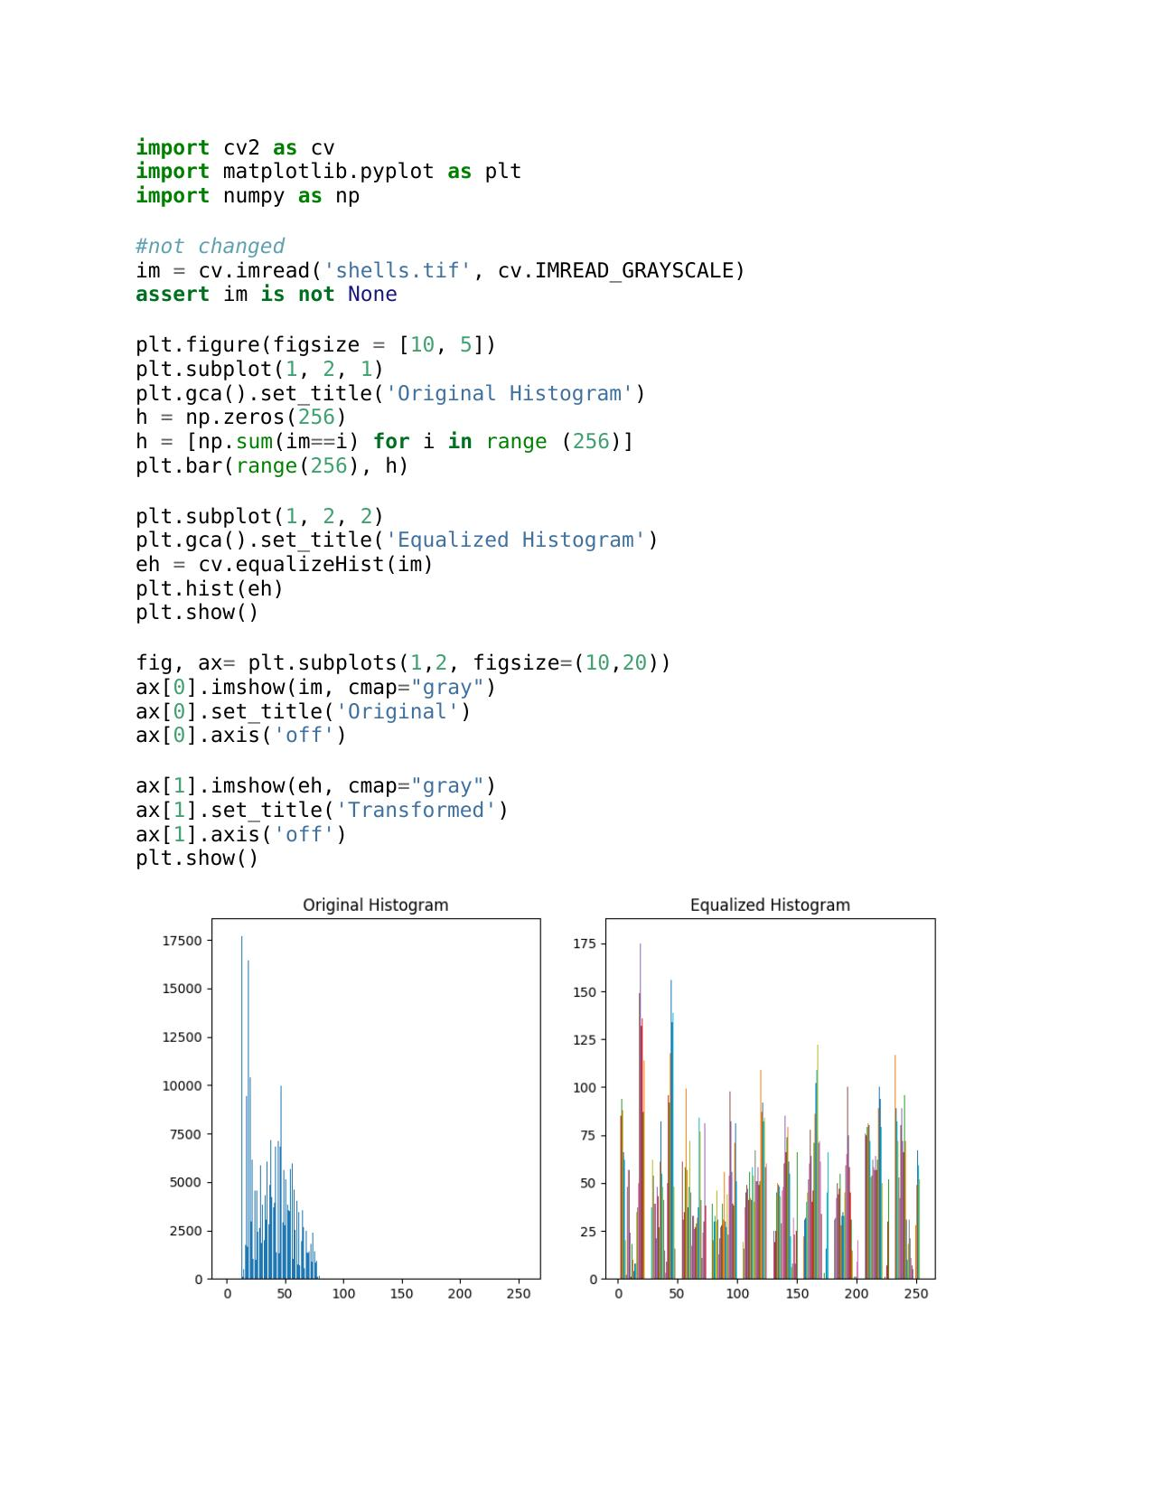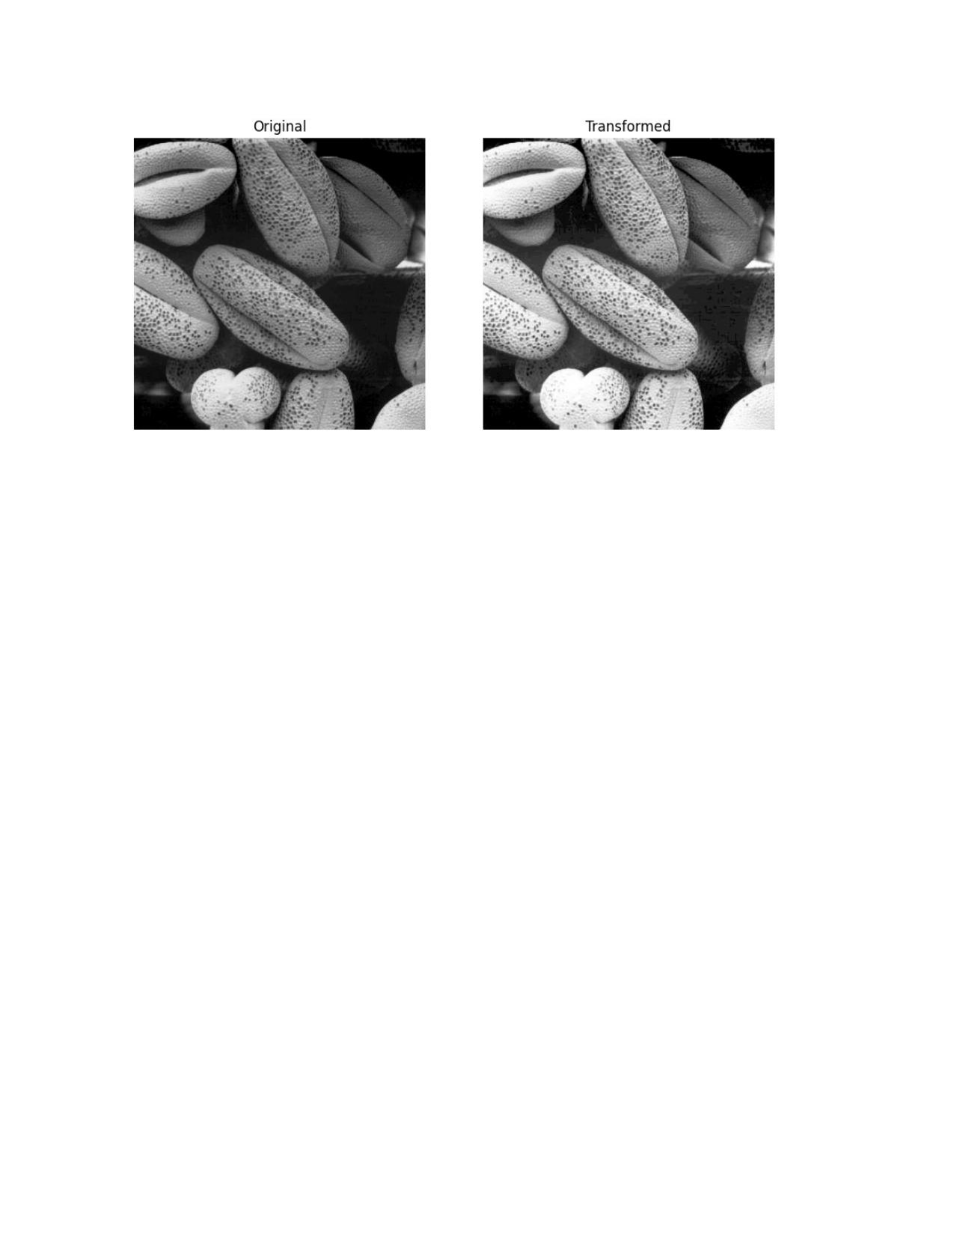

**Question 05**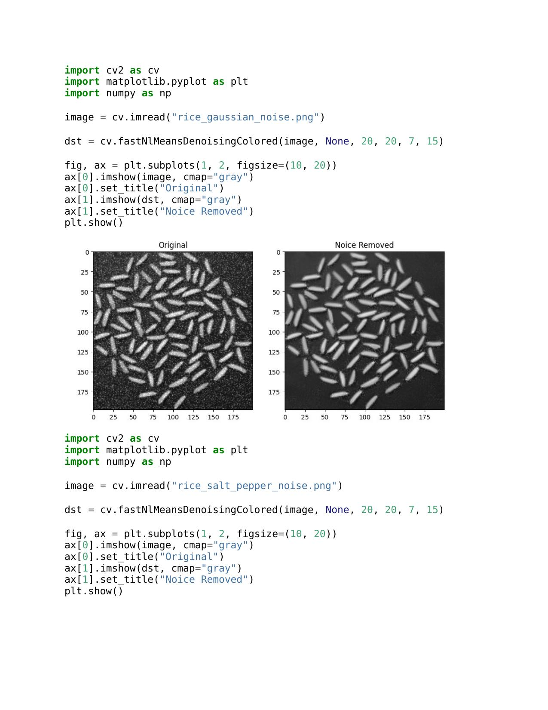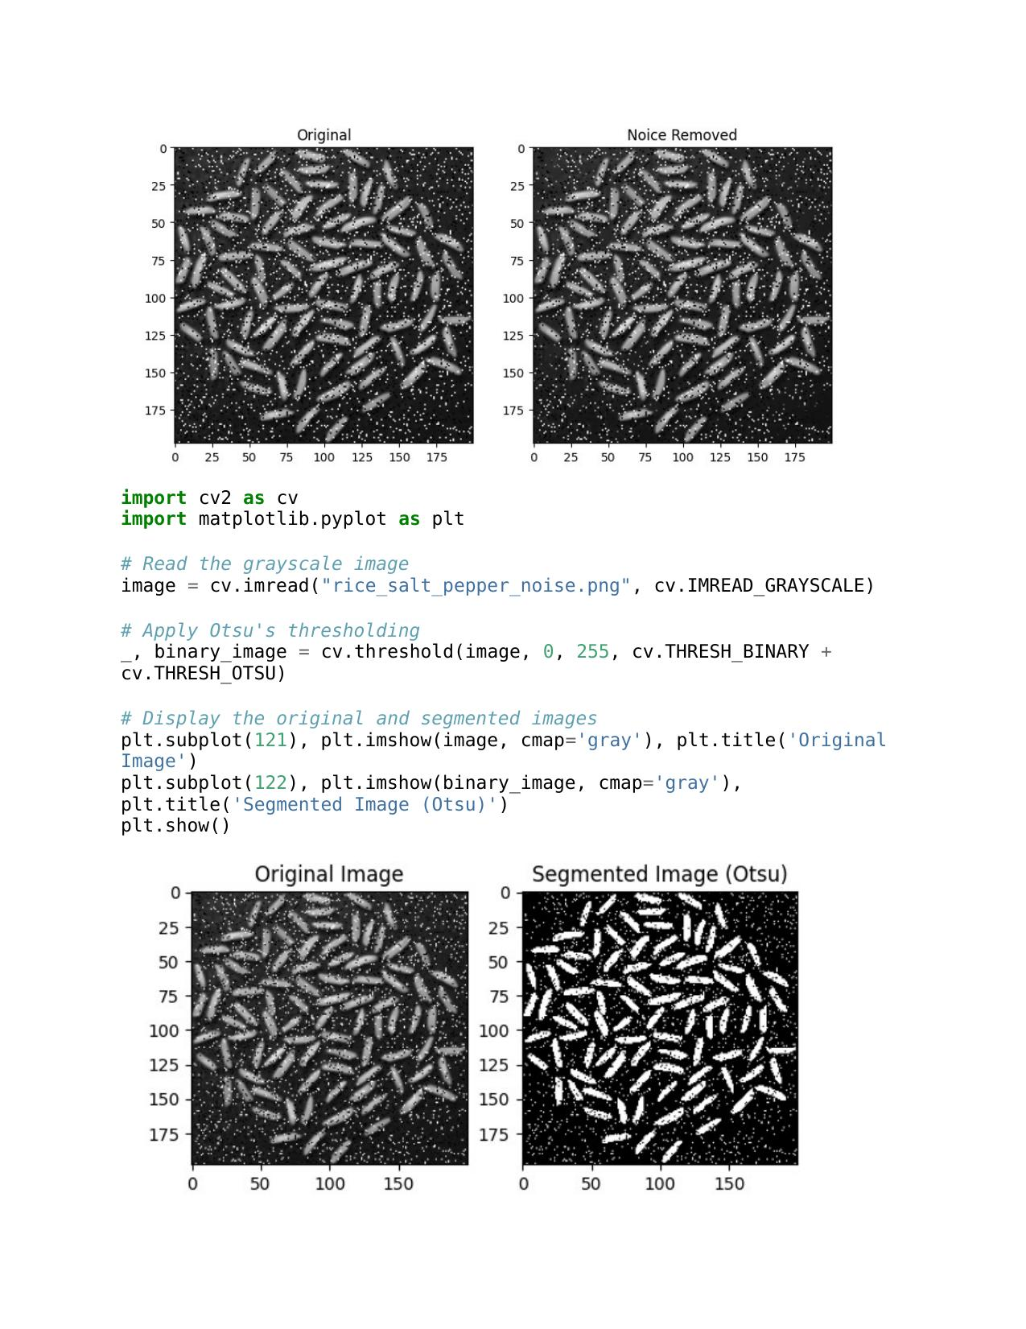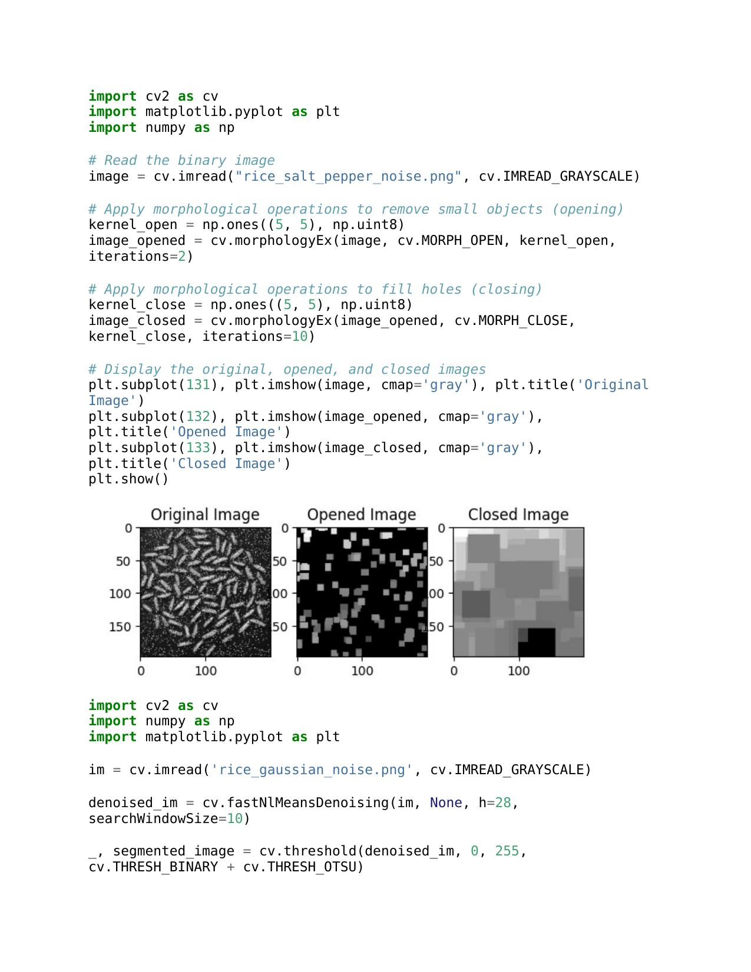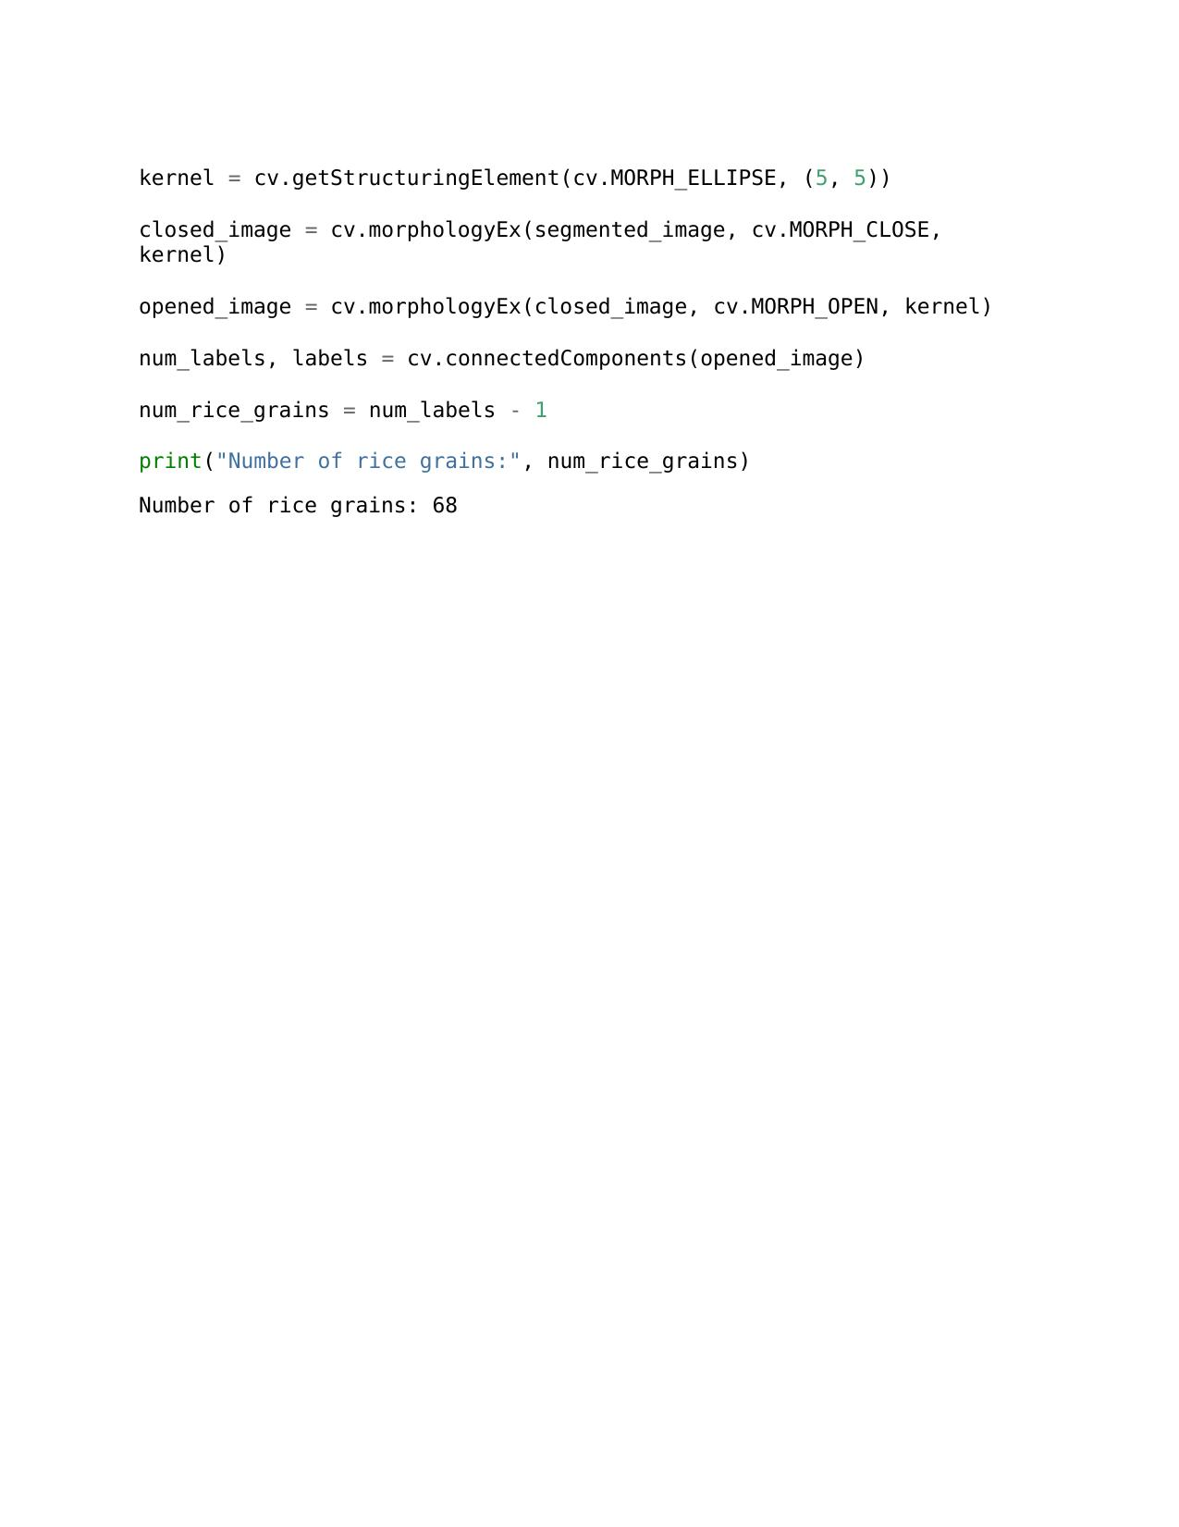

b.

a.

c.

e.

d.

**Question 06**

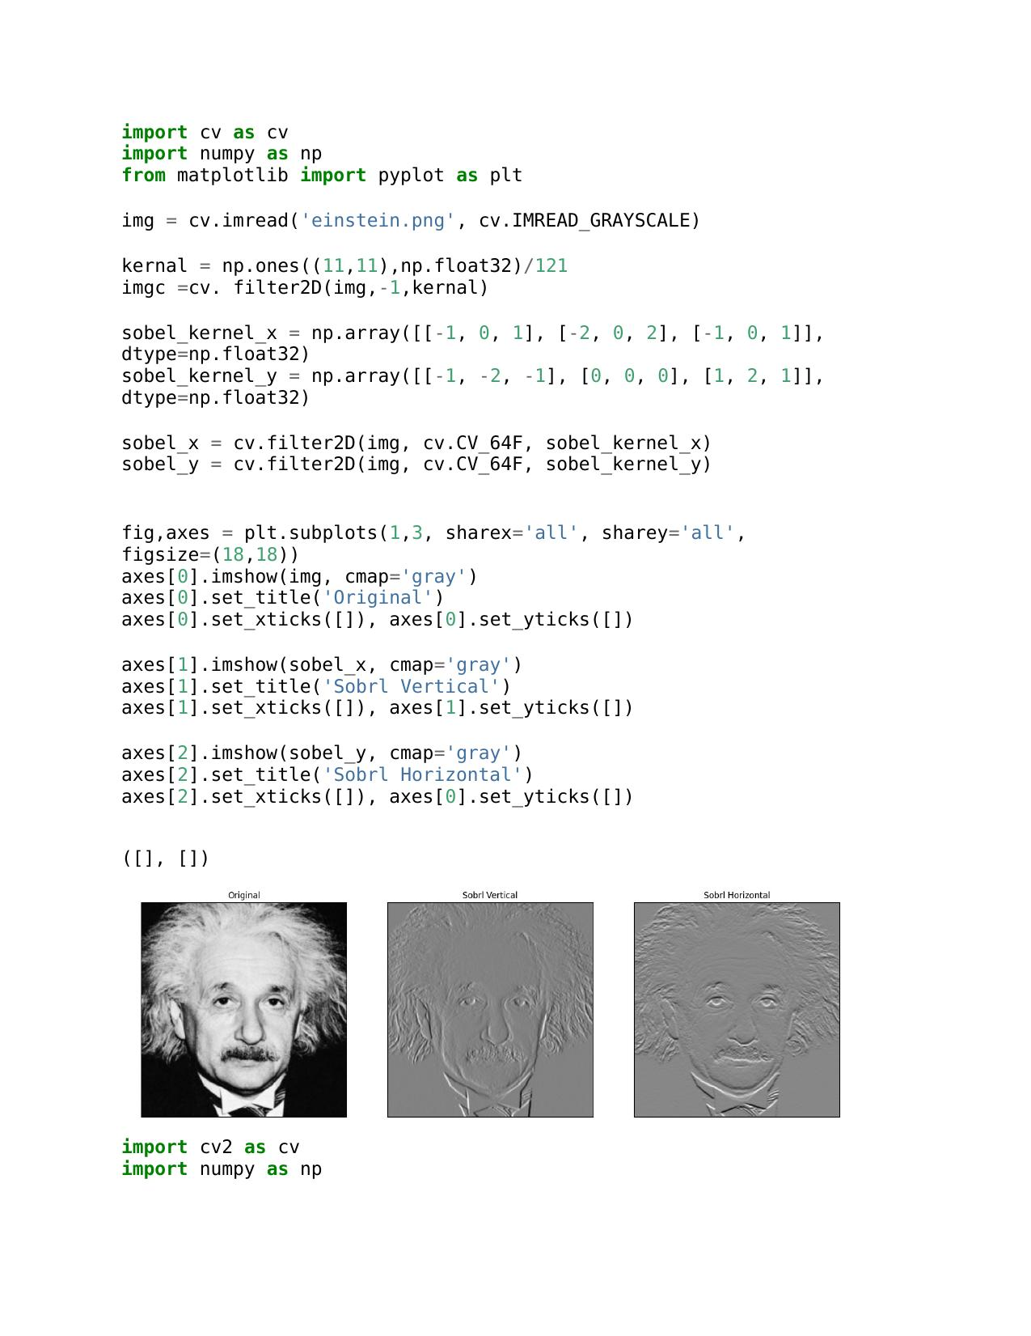

b..

a.

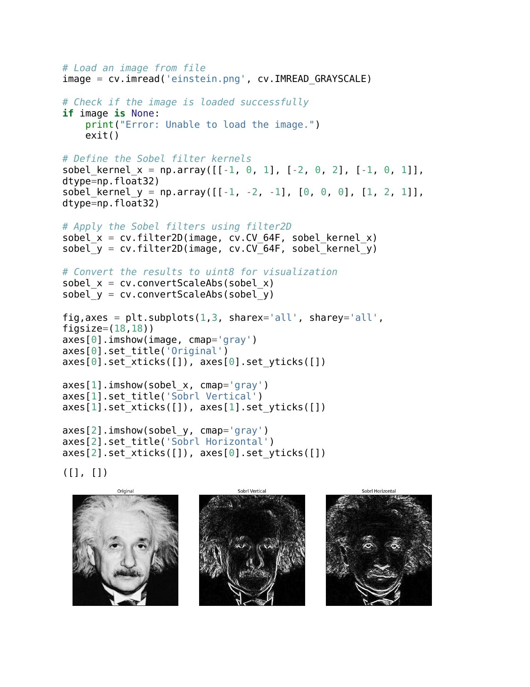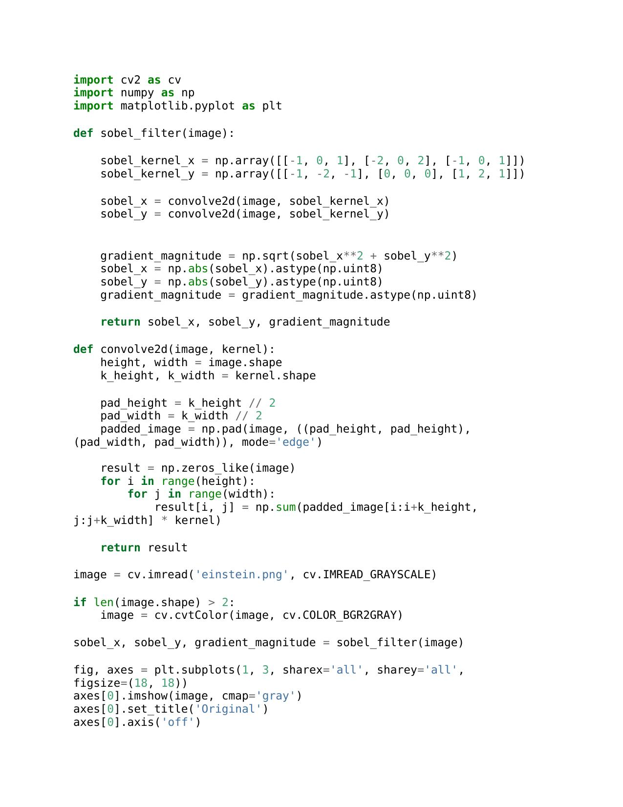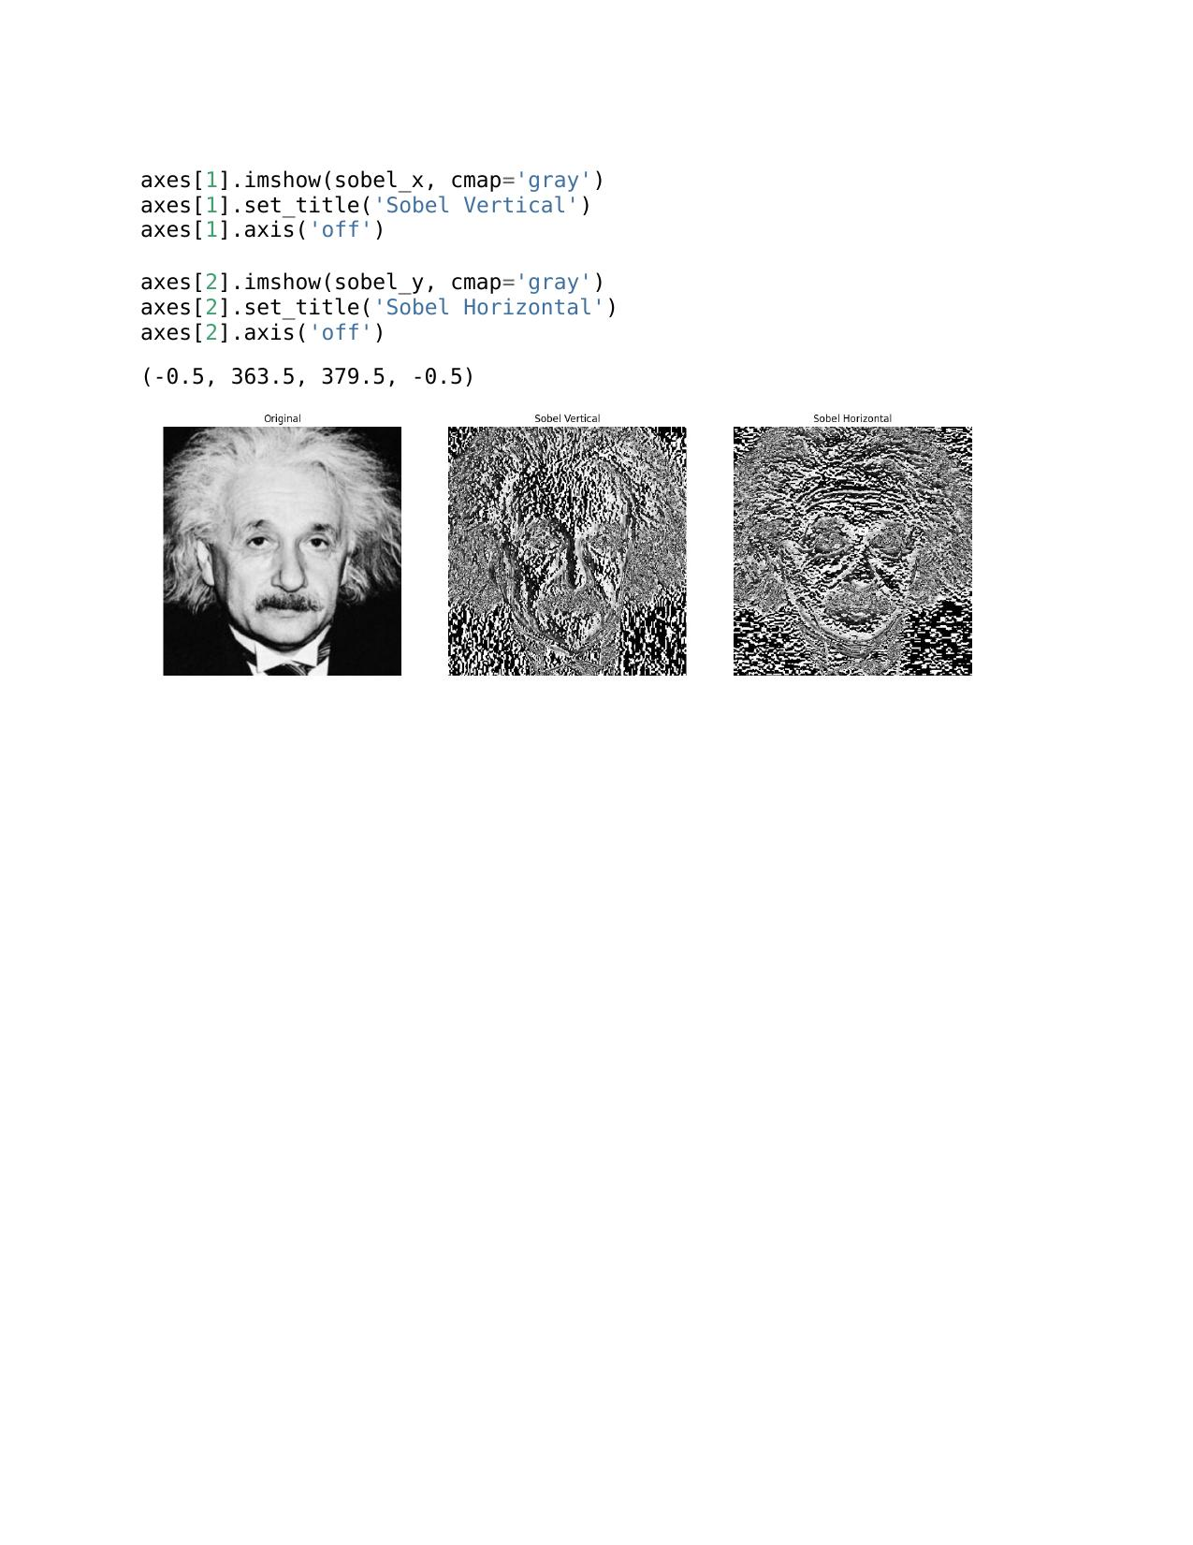

c.

**Question 07**

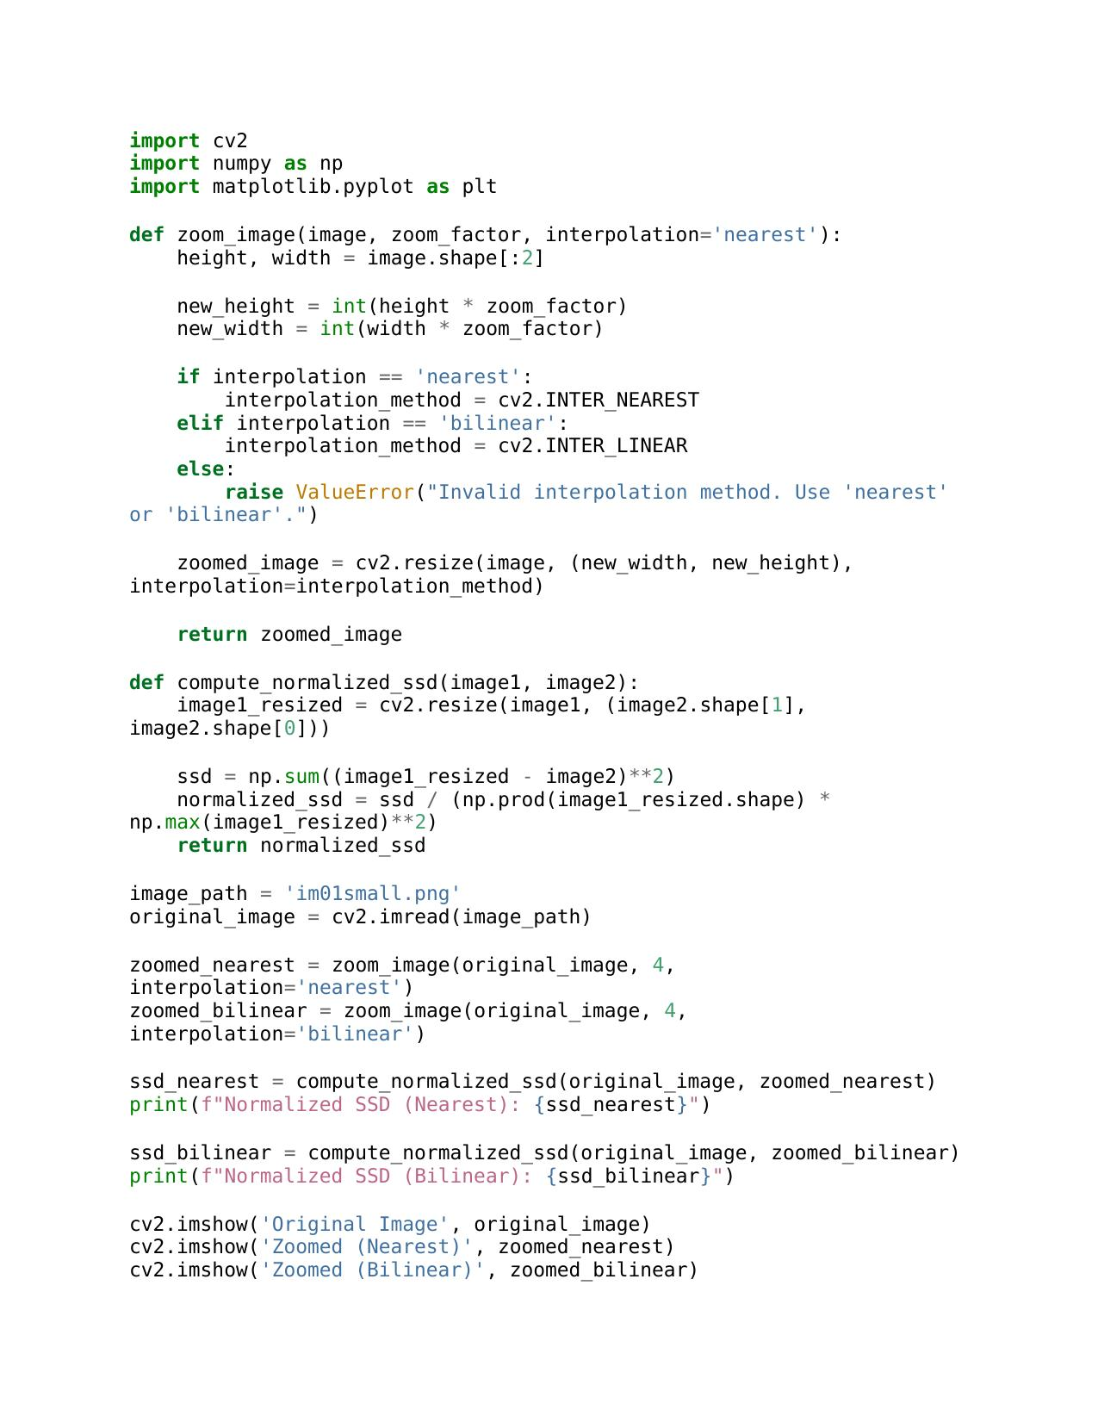

a.

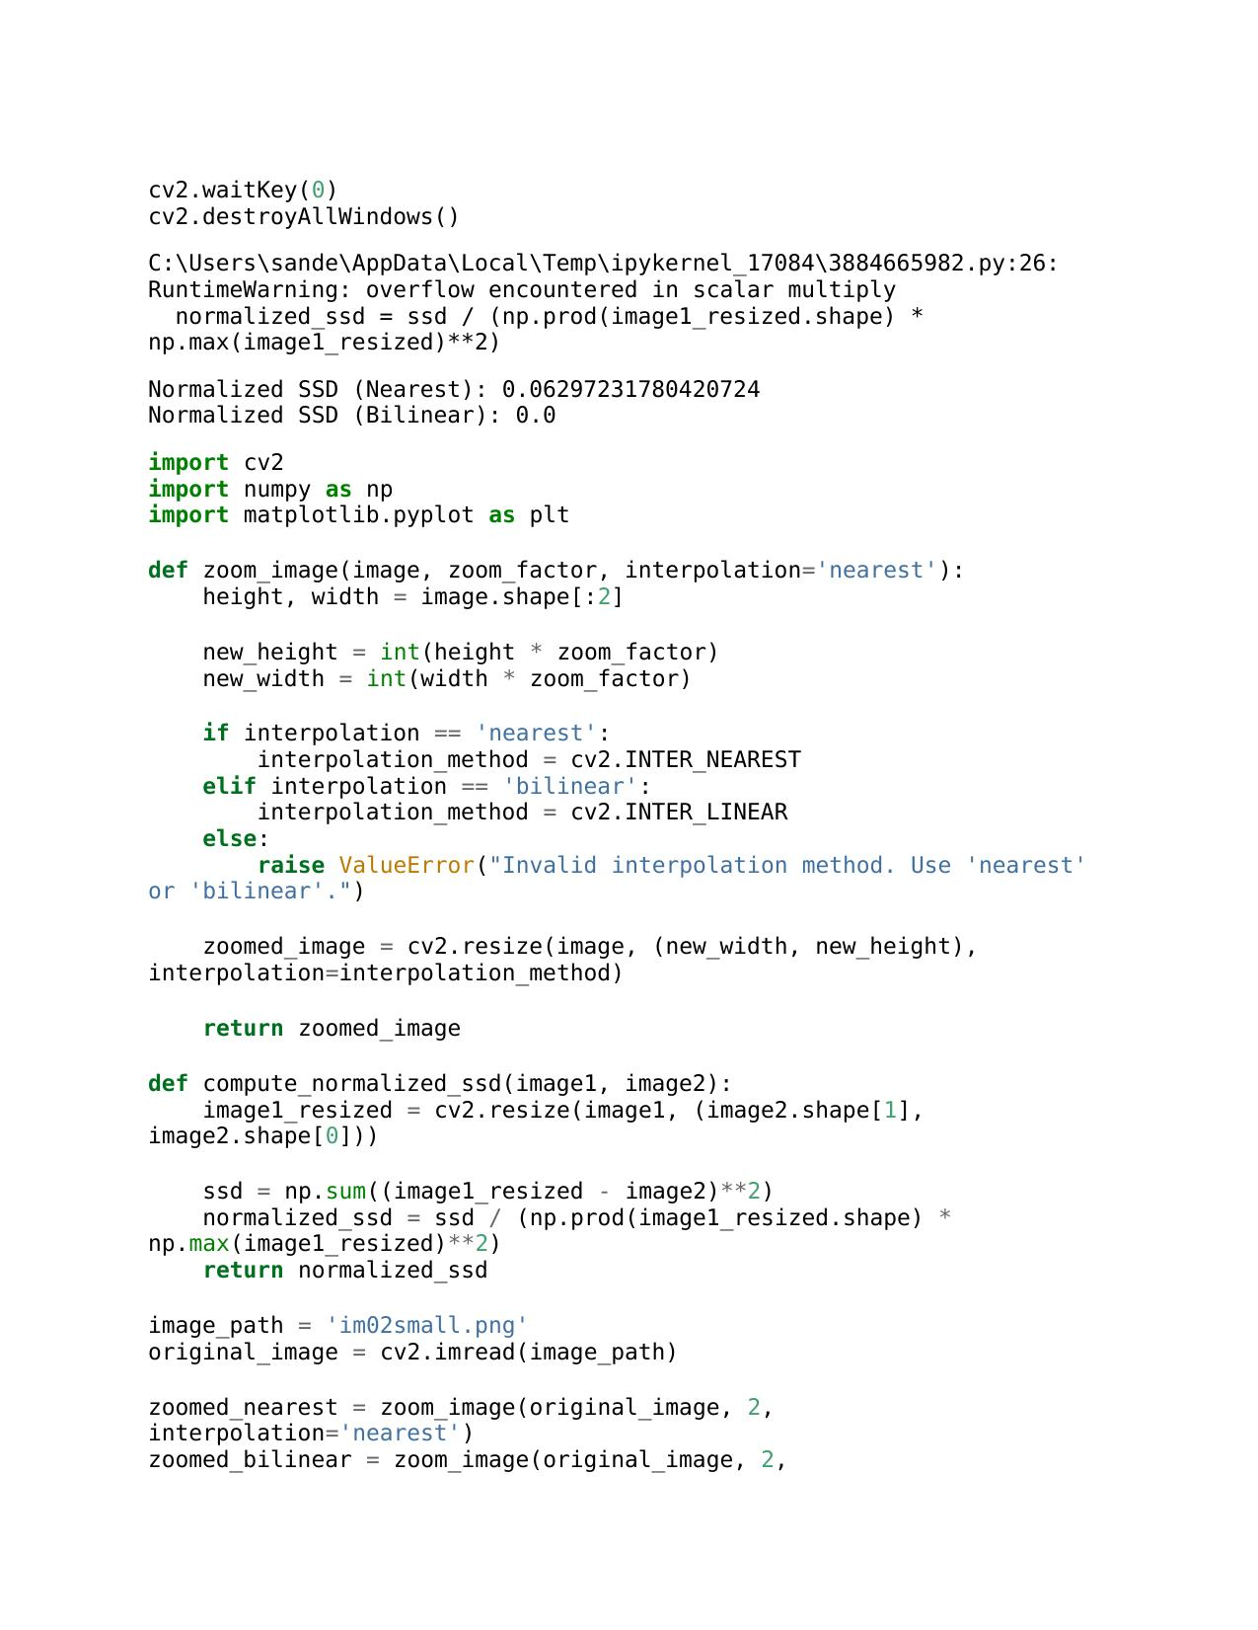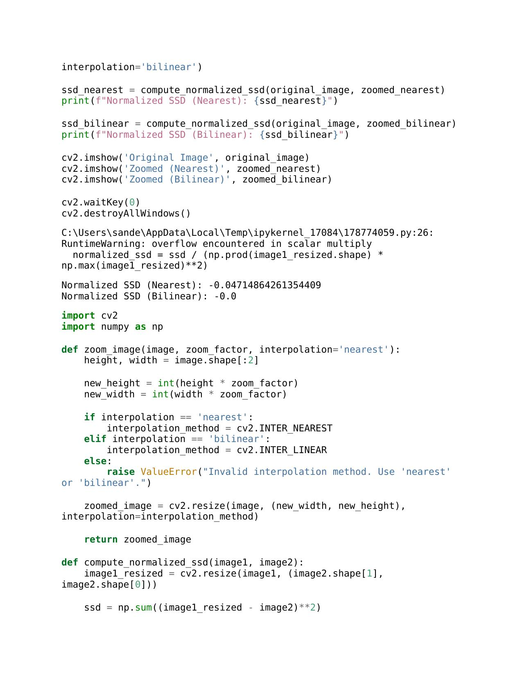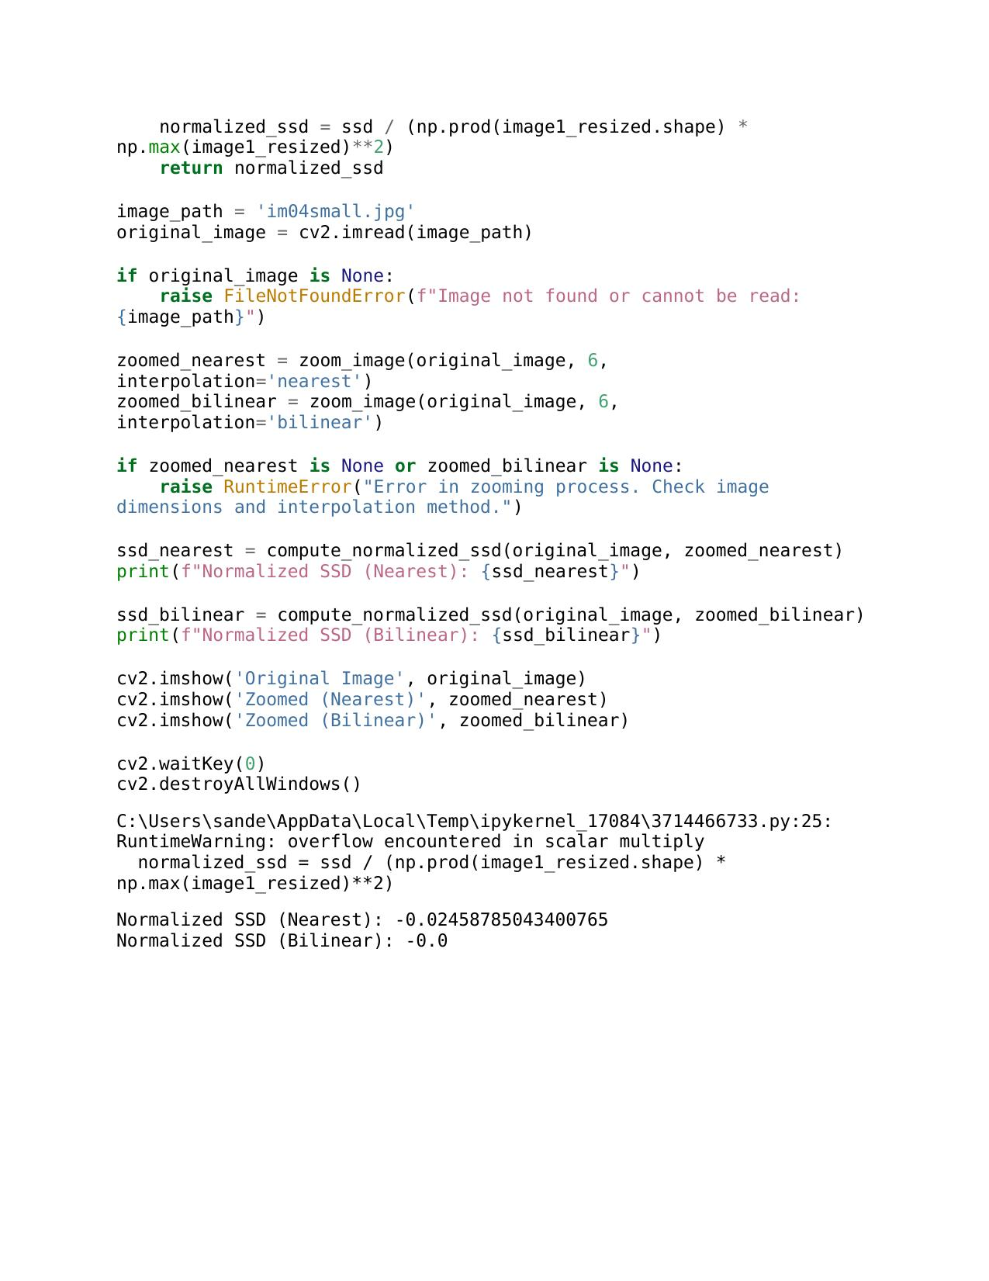

b.

In assignment question 7, I worked with four different types of images, using specific codes for each to resize them effectively. I tailored the codes to suit the unique characteristics of each image, ensuring accurate and successful transformations. And I tested these images using 4 different codes and those are good to go. I entered the codes separately for the each image.

**Question 08**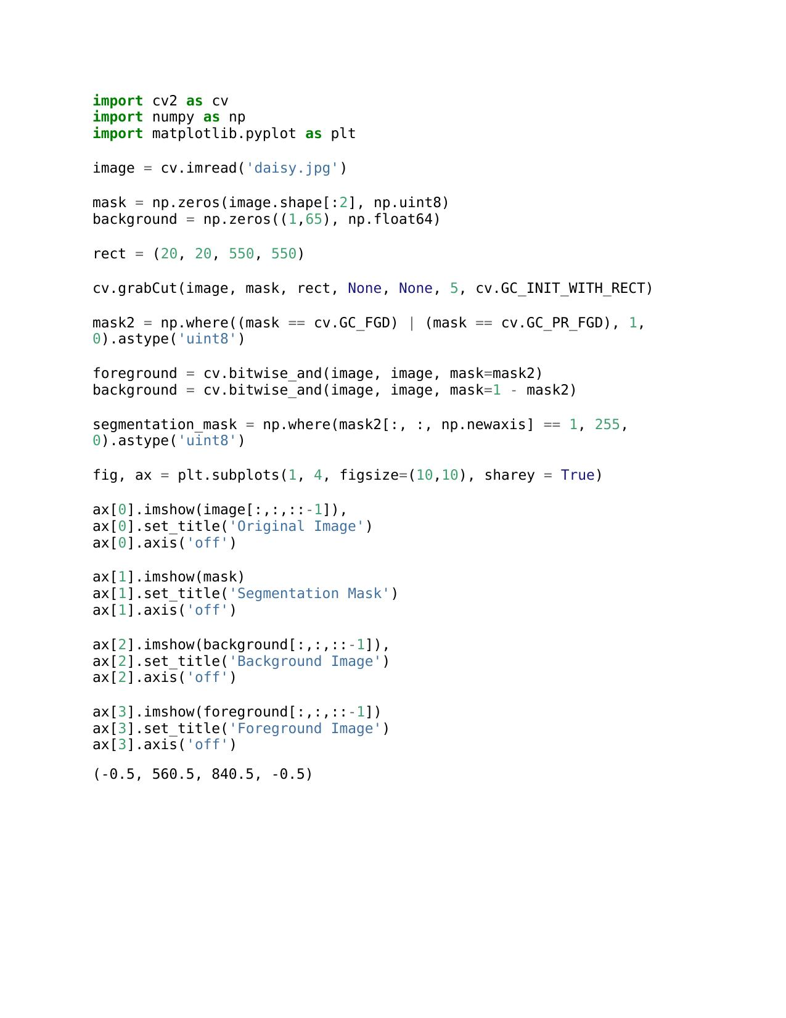

a.

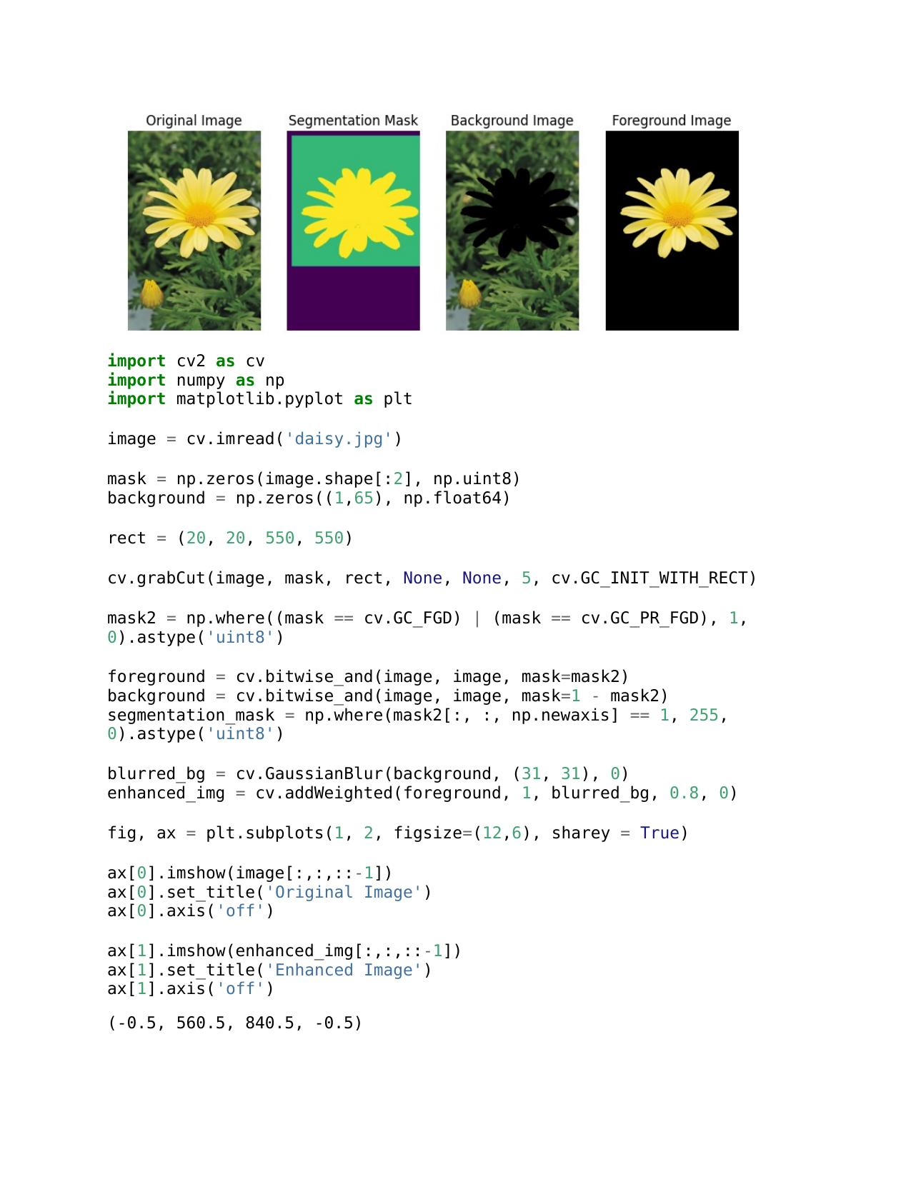

b.

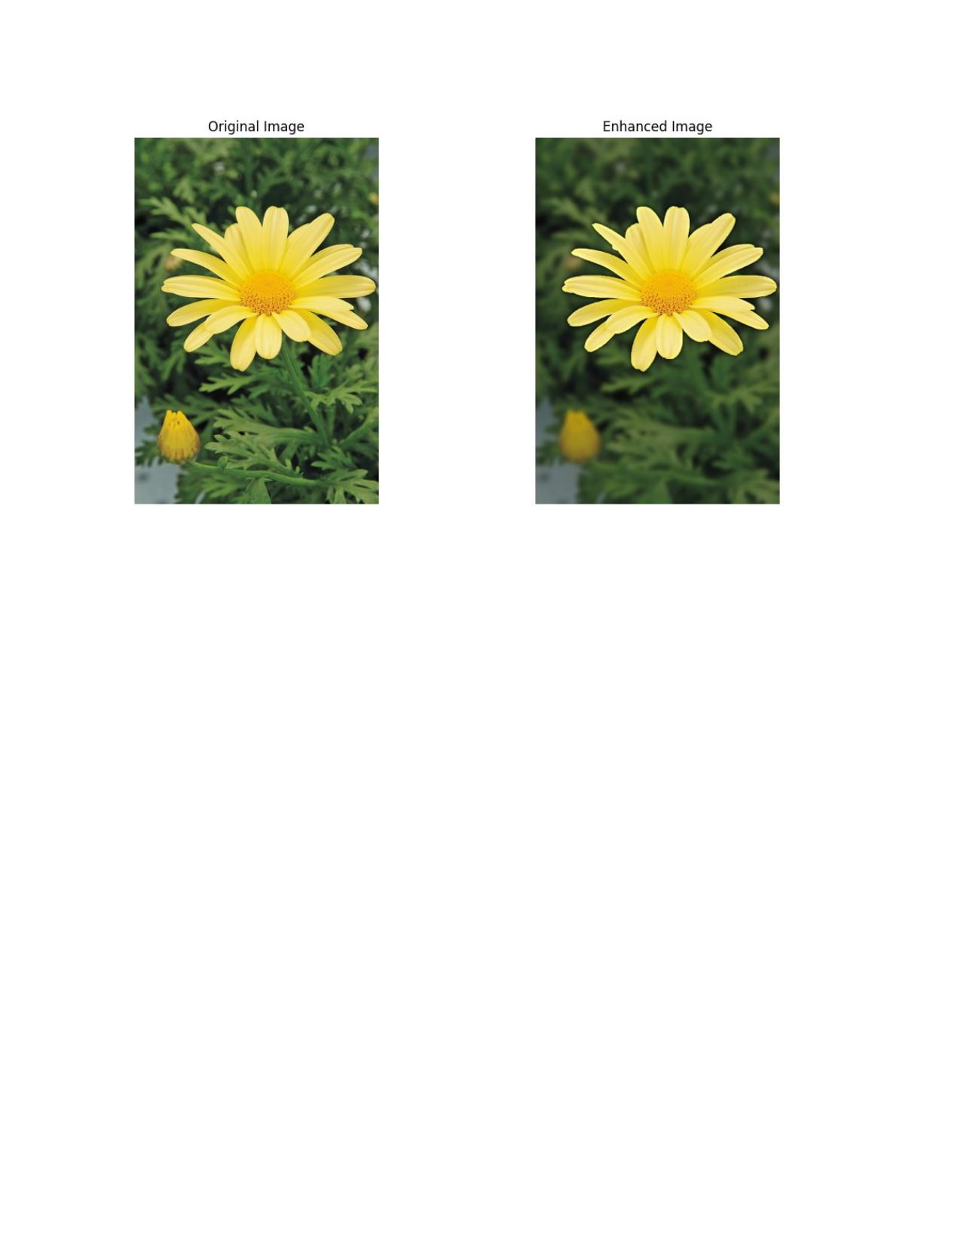

**c.** The improved image's darker backdrop, which extends over the margin of the flower, is mostly the outcome of a Gaussian blur applied to the background. The image is first divided into foreground (flower) and background using Grab Cut. The background is then smoothed using a Gaussian blur with a (15, 15) kernel. The backdrop appears darker because of this smoothing effect, which averages pixel values. The final improved image is produced by combining the sharp foreground with the blurred backdrop. The degree of blurring and the ensuing darkness in the backdrop can be altered by varying certain parameters, such as the kernel size.

**GitHub Link**

<https://github.com/Sandeepa0/Image-Processing.git>